Enemy AI 2D
In this tutorial we'll create a simple code for the enemy Ai for 2D. You will learn to code:
Patrol
or
Follow Player
I would assume you know the basics of Unity editor as well we will be tutorial Unity 5/2018.
Patrol Enemy AI
To add a character sprite to game, simply drag and drop it from the Project folder into the Scene view. To see for how easy the process is, select the Scene view, then drag the character sprite from the Sprites folder into your Scene view.
Created a folder for the code Enemy as well create a new C# Script call it Patrol and put inside the Code Enemy ai folder and attach it to the enemy character. Writing down the following code and some of the code will be able in notepad to look at:
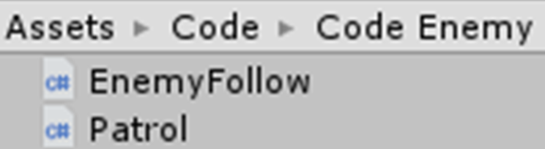

Writing down the following code :
Patrol: using UnityEngine;
public class Patrol : MonoBehaviour{
public float speed;
private float distance = 0.0f;
private bool movingRight= true;
public Transform grounsDetection;
void Update(){
transform.Translate(Vector2.right * speed * Time.deltaTime);
RaycastHit2D groundInfo = Physics2D.Raycast(grounsDetection.position,Vector2.down,distance);
if(groundInfo.collider != null){
if(movingRight == true){
transform.eulerAngles = new Vector3(0F, -180F, 0F);
movingRight = false;
}else{
transform.eulerAngles = new Vector3(0F, 0F, 0F);
movingRight = true;}
}
}
}

Follow Player Enemy AI
To add a character sprite to game, simply drag and drop it from the Project folder into the Scene view. To see for how easy the process is, select the Scene view, then drag the character sprite from the Sprites folder into your Scene view.
Created a folder for the code Enemy as well create a new C# Script call it Follow Player and put inside the Code Enemy ai folder and attach it to the enemy character. Writing down the following code and some of the code will be able in notepad to look at:
Writing down the following code :
using UnityEngine;
public class EnemyFollow : MonoBehaviour {
public float speed;
public float stoppingDistance;
private Transform target;
void Start () {
target = GameObject.FindGameObjectWithTag("Player").GetComponent<Transform>();}
void Update () {
if (Vector2.Distance(transform.position,target.position) >stoppingDistance){
transform.position = Vector2.MoveTowards(transform.position, target.position, speed * Time.deltaTime); }
}
}

